

Fitocity - Health & Fitness Management System

System Requirements Specifications (SRS) Document

**Submitted by**

FA20 - BSE - 085 - Muhammad Suhaib Iqbal

FA20 - BSE - 086 - Shaheer Ahmad

FA20 - BSE - 149 - Saim Abbas

BSE - 5 -B  
Software Quality Engineering

Software Requirements Specification

Fitocity - HFMS

**Version**  
1.0 Approved

**Prepared by**

M Suhaib Iqbal  
Shaheer Ahmad  
Saim Abbad

**Organization:**Comsats University Islamabad – Wah Campus

**Dated:**  
09/01/2023

|  |  |  |  |
| --- | --- | --- | --- |
| Revision History | | | |
| Date | Revision | Description | Author |
| 12/19/2022 | 1.0 | Final Revision | Suhaib, Shaheer, Saim |
|  |  |  |  |
|  |  |  |  |

**Table of Contents**  
1. Introduction

1.1. Purpose

1.2. Scope

1.3. Definitions, Acronyms, and Abbreviations

1.4. References

1.5. Assumptions and Dependencies

2. Use Case Model Survey

3. Actor Survey

4. Requirements

4.1. Functional Requirements

4.2. Non-Functional Requirements

5. User Documentation and Help System Requirements

6. Design Constraints

7. Purchased Components

8. Software Interfaces

9. Licensing and Security Requirements

10. Legal, Copyright, and Other Notices

11. Applicable Standards

12. Index

13. Glossary

14. Appendixes

**1. Introduction**

**1.1. Purpose**The purpose of this document is to analyze and define the detailed vision and scope of Fitocity. The document proposes the baseline for the software system. The document defines the scope of the software, use cases, functional and non functional requirements and all other aspects of software system briefly.

**1.2. Scope**. The product will beneficial for those who use computer on daily bases and doesn’t have enough time to take a look on their physical health. They will be notified about their health and when they need to take their meal or the glass of water.

**1.3. Definitions, Acronyms, and Abbreviations**None Specified.

**1.4. References**[1] Fitocity Prototype done in Figma  
https://www.figma.com/proto/M0E9ziRpzGaei2wuN106vs/

**1.5. Assumptions and Dependencies**Some of the modules of the system might be dependent on other hardware or software components. The complete software is dependent on the JAVA development environment. There are also some other libraries which the system is dependent on:  
- Java Swing  
- Java UTIL

# **2. Use Case Model Survey**

**Use Cases:**

* + Registration of use account.
  + Login System.
  + Profile view.
  + Dashboard.
  + Game.
  + Setting

|  |  |
| --- | --- |
| **Use Case ID** | **01** |
| **Use case Name** | Login |
| **Description** | User will enter the system with username and password |
| **Pre- Condition** | Account for the user exists |
| **Post Condition** | Enters the system -> dashboardView(); |
| **Exception** | Wrong username or password |

|  |  |
| --- | --- |
| **Use Case ID** | **02** |
| **Use case Name** | Register |
| **Description** | User will register in the system for the first time in a 3 step mechanism |
| **Pre- Condition** | Account with provided username doesn’t exist |
| **Post Condition** | User will enter the system for first time |
| **Exception** | Username already exists. |

|  |  |
| --- | --- |
| **Use Case ID** | **03** |
| **Use case Name** | Enter Profile |
| **Description** | User enters profile by clicking on menu by dashboard |
| **Pre- Condition** | User should be logged in |
| **Post Condition** | User enters profile |
| **Exception** | System Error |

|  |  |
| --- | --- |
| **Use Case ID** | **04** |
| **Use case Name** | Enter Dashboard |
| **Description** | User enters dashboard by log in to ID |
| **Pre- Condition** | User should be logged in |
| **Post Condition** | User enters Dashboard |
| **Exception** | System Error |

|  |  |
| --- | --- |
| **Use Case ID** | **05** |
| **Use case Name** | Enter Settings |
| **Description** | User enters settings by clicking on settings from menu |
| **Pre- Condition** | User should be logged in |
| **Post Condition** | User enters settings |
| **Exception** | System Error |

|  |  |
| --- | --- |
| **Use Case ID** | **06** |
| **Use case Name** | Enter Game |
| **Description** | User enters game by clicking on game from menu |
| **Pre- Condition** | User should be logged in |
| **Post Condition** | User enters game |
| **Exception** | System Error |

**3. Actor Survey**.

|  |  |
| --- | --- |
| **Actor** | **Description** |
| General User | The one and only end user/General user actor will be able to perform all the tasks in the software system for himself. The software is self sufficient intelligence based software and does not require another actor. |

**4. Requirements**.

**4.1. Functional Requirements**. ● User signup and login

Different user must be able to register their separate profile and log in to the system using their username and password.

● Calculating BMI

While signup process the user enters in weight and height after that BMI is calculated. Meals and exercises are recommended to the user considering that BMI.

● Glass of water count

The application has a water count and the user can update it by himself.

● Profile setting

The system has a settings option in which user can change its registered profile settings like username password etc.

**4.2. Non-Functional Requirements**- Functional suitability

The features and functions of the software are tested and reviewed and are thus stable. They are equally sustainable in a stressed and loaded environment.

* Reliability

The software system is reliable to be used in the respective market domain by all kinds of people who are concerned about their physical health.

* Security

The software system keeps the confidential information of all the users profile safe.

* Compatibility

The first final version of the software system is easy to deploy and requires just the installation of JAVA and the respective development environment.

**5. User Documentation and Help System Requirements**- A user manual must be included with the software in order to help users understand the basics of the system.  
- A video guide explaining users who are not familiar with technical knowledge.

**6. Design Constraints  
Language Used**JAVA  
  
**IDE Used**Eclipse, IntelliJ IDEA

**7. Purchased Components**None

**8. Software Interfaces**The software has number of interfaces that the user will go through once he is using the application.

* Welcome screen
* Signup
* Profile setup
* Login
* Dashboard

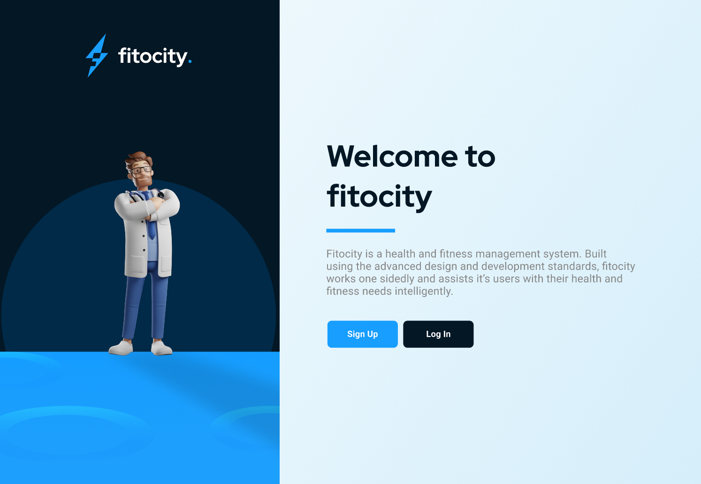

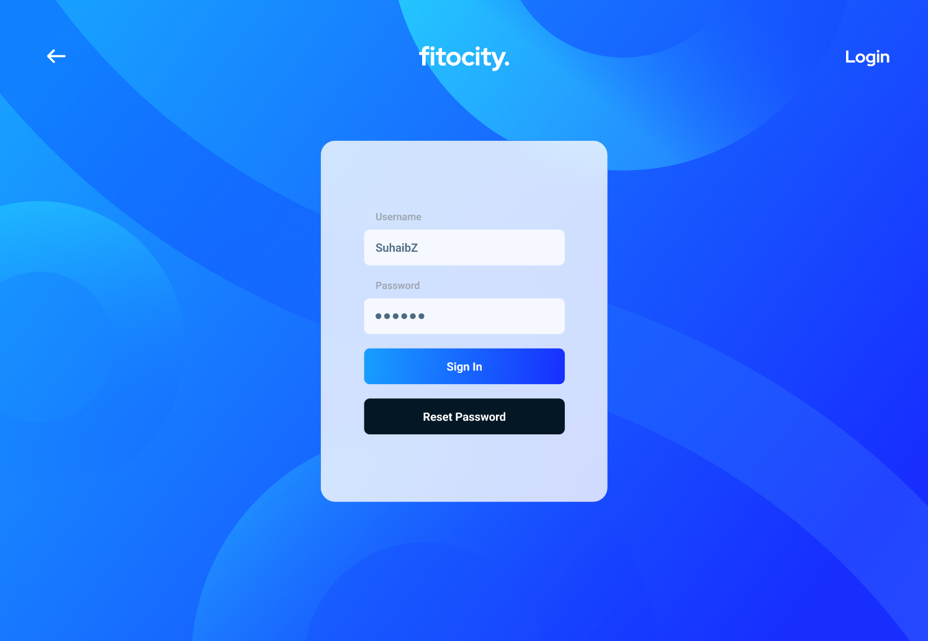

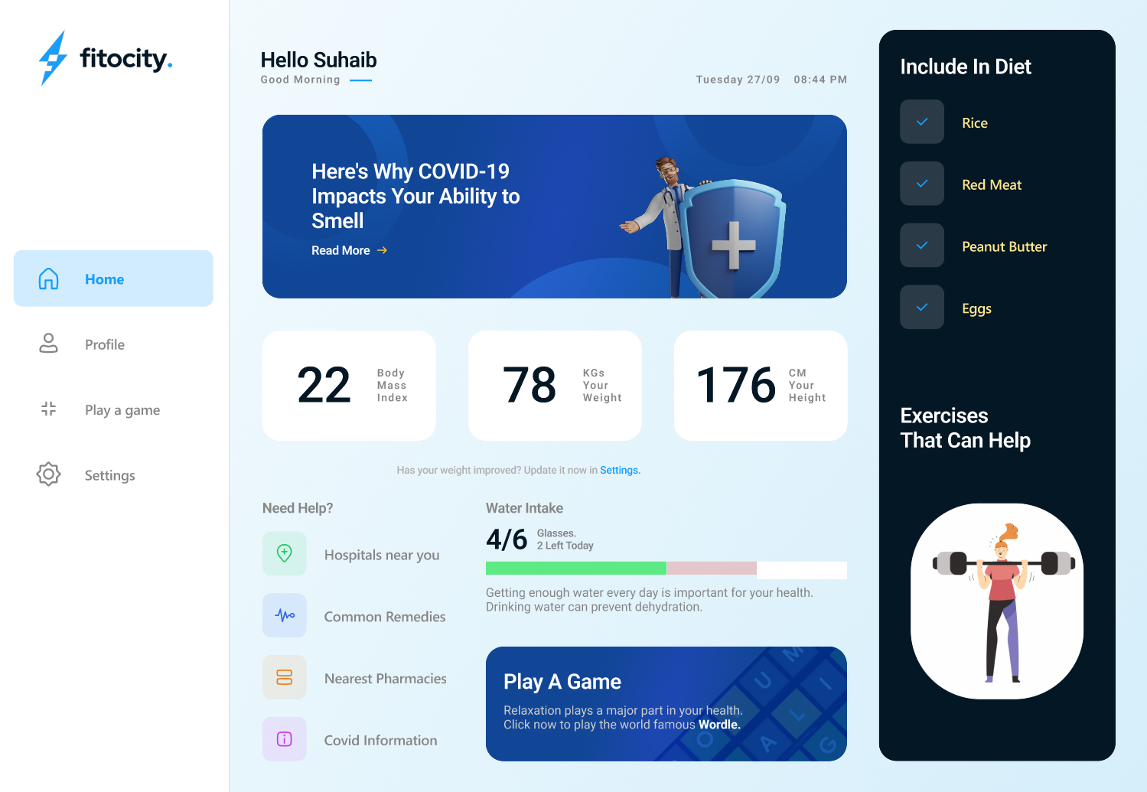

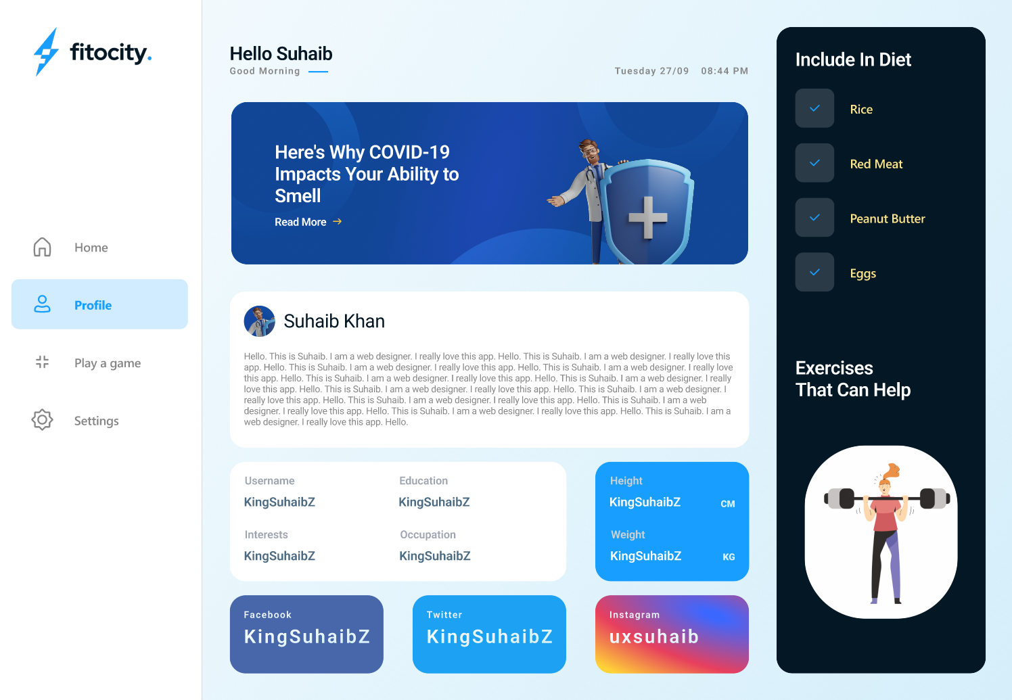

**9. Licensing and Security Requirements**N/A

**10. Legal, Copyright, and Other Notices**N/A  
  
**11. Applicable Standards**All the IEEE specified standards for a computer based software system.

**12. Index**In table of contents.

**13. Glossary**IEEE = Institute of Electrical and Electronics Engineers

**14. Appendixes**

**14.1 Pseudocode**

**14.1.1 Login Module**

1. Input username, password

2. if username exists in database then

Redirect to dashboard

else

return back with error message

**14.1.2 Weight Preference Module**

1. Input weight, height

2. bmi ← (weight/height)

3. if (bmi<18.5) then

print “Gain Weight”

else if (bmi>=18.5 and bmi<25) then

print “Maintain Weight”

else

print “loose weight”

**14.2 Flowchart**

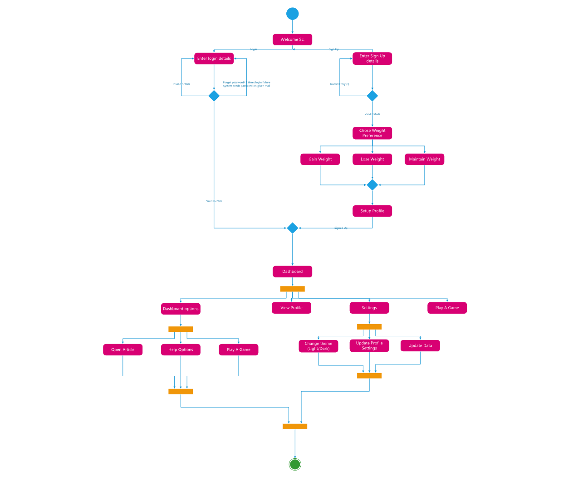

**14.3 ER Diagram**

**14.4 Class Diagram**

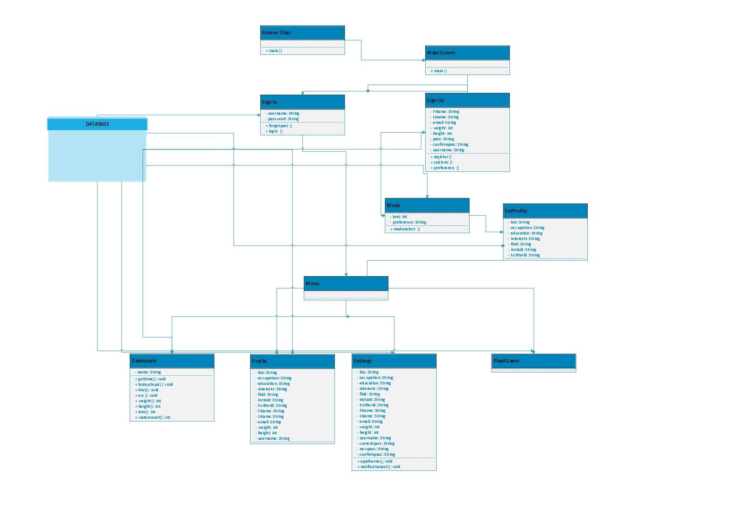

**14.5 State Transition Diagram**

